AML DASHBOARD

Using Microsoft Power BI

Project Report
Submitted By:
Name: KEVIDYA T E
Roll.no: E25FA055
Tool Used: Microsoft Power BI Desktop

Power BI Report
AML Transaction & Fraud Analysis Dashboard

1. Introduction
Anti-Money Laundering (AML) monitoring is important in banking and financial services. Banks handle a large number of transactions every day, while only a small number may be fraudulent or suspicious. Power BI helps present transaction information clearly so unusual activity can be noticed more easily.
This report explains the AML Transaction & Fraud Analysis dashboard created in Microsoft Power BI Desktop using the data shown in the supplied dashboard screenshots. It summarises transaction activity, compares fraudulent and non-fraudulent transactions, analyses transaction patterns over time, and reviews alerts by type. The report includes the main dashboard, an interactive dashboard with slicers, and a tooltip page.

2. Objectives
- To summarise transaction activity using key performance indicator (KPI) cards.
- To compare fraudulent and non-fraudulent transactions by count and value.
- To observe overall and fraudulent transaction volumes across timestamps.
- To compare the number of alerts for each alert type.
- To make the report interactive using Fraud Status and Alert Type slicers.

3. Dataset Description
The dashboard uses three tables shown in the Power BI Data pane: Transactions, Accounts and Alerts. The visible fields and their uses are summarised below.
Table | Fields used | Description
Transactions | TIMESTAMP, IS_FRAUD | Contains transaction records, including timestamp and the fraud-status field used in the charts.
Accounts | Account records | Contains account records used for the Total Account KPI.
Alerts | ALERT_ID, ALERT_TYPE | Contains alert records, including ALERT_ID and ALERT_TYPE (cycle and fan_in).

The dashboard cards display TOTAL TRANSACTION, TOTAL TRANSACTION AMOUNT, TOTAL ACCOUNT and FRAUDULENT TRANSACTIONS. The charts use transaction timestamp, fraud status, transaction amount and alert type to summarise the data.

4. Tools Used
- Microsoft Power BI Desktop for data modelling, DAX measures and dashboard design.
- DAX (Data Analysis Expressions) for the calculated measures.
- A clean, light report layout with dark blue-grey charts for clear comparison.

5. Dashboard Overview
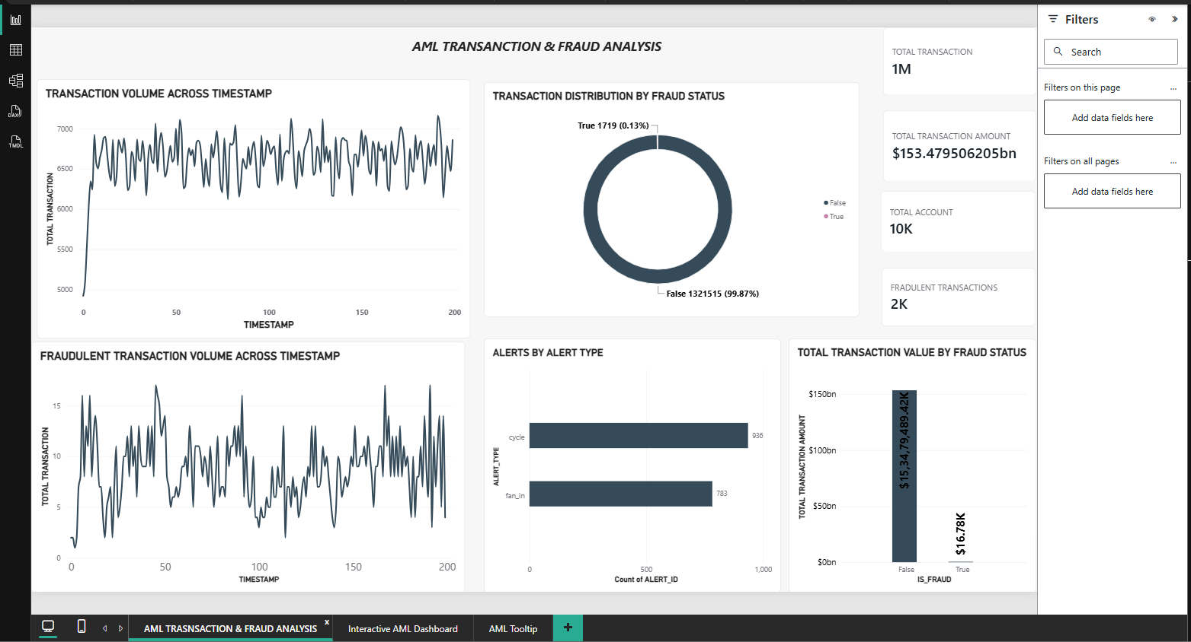
The main page, AML TRANSACTION & FRAUD ANALYSIS, presents the key figures and charts together. It includes transaction volume over time, fraud distribution, fraudulent transaction volume, alert counts by type and transaction value by fraud status.

6. Key Performance Indicators (Cards)
Four KPI cards summarise the main figures in the supplied dashboard. They help the viewer understand the overall scale of transactions, transaction value, accounts and flagged fraudulent transactions.
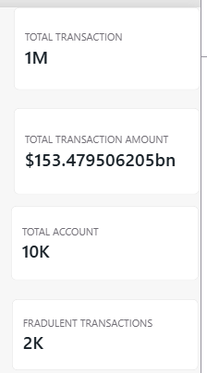
Figure 2: KPI cards from the supplied dashboard
KPI | Value | Meaning
Total Transaction | 1M | Total number of transactions shown by the KPI card.
Total Transaction Amount | $153.479506205bn | Combined value of transactions shown by the KPI card.
Total Account | 10K | Total number of accounts shown by the KPI card.
Fraudulent Transactions | 2K | Approximate number of transactions flagged as fraud.

Purpose:
- To show the scale of activity being monitored.
- To show the size of the fraud problem against total activity.
- To give a quick summary without opening the detailed charts.

7. Visualizations Used

Transaction Volume Across Timestamp
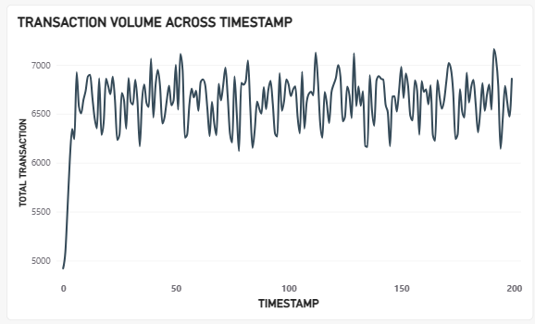
Figure 3: Transaction Volume Across Timestamp
A Line Chart shows the total transaction volume across timestamps from approximately 0 to 200.
The chart begins at about 4,900 transactions, rises quickly, and then fluctuates mostly between about 6,200 and 7,100. This shows that transaction volume stays within a fairly steady range after the initial rise.
Purpose:
- To track transaction activity over time.
- To identify spikes or drops in volume.
- To establish a normal baseline for monitoring.

Fraudulent Transaction Volume Across Timestamp
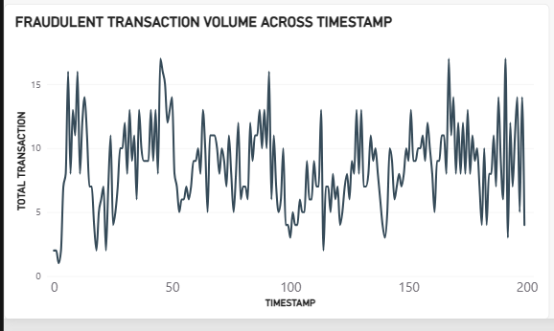
Figure 4: Fraudulent Transaction Volume Across Timestamp
A Line Chart shows the number of fraudulent transactions at each timestamp.
The fraudulent transaction line changes frequently, generally ranging from around 1 to 17 transactions per timestamp. The repeated rises and falls show that fraudulent activity is irregular rather than steady.
Purpose:
- To observe when fraudulent activity rises or falls.
- To compare fraud behaviour with overall transaction behaviour.
- To help decide when closer monitoring is needed.

Transaction Distribution by Fraud Status
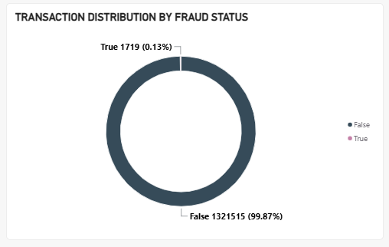 Figure 5: Transaction Distribution by Fraud Status
A Donut Chart compares transactions marked False and True in the IS_FRAUD field.
The chart shows that about 99.87% of transactions are marked False and about 0.13% are marked True. This indicates that transactions flagged as fraud form a very small share of the overall transaction data.
Purpose:
- To show the proportion of fraud against normal transactions.
- To highlight how imbalanced the data is.
- To give context for the fraud KPI.

Alerts by Alert Type

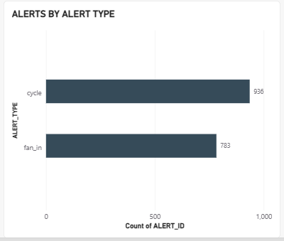

Figure 6: Alert by Alert Type
A Bar Chart compares the number of alerts for each alert type.
The dashboard shows 936 CYCLE alerts and 783 FAN_IN alerts. CYCLE alerts are more common in this data. CYCLE refers to money moving through a chain of accounts and returning to its origin, while FAN_IN refers to multiple accounts sending money to one account.
Purpose:
- To compare alert volumes by type.
- To identify the most common suspicious pattern.
- To help prioritise investigation effort.

Total Transaction Value by Fraud Status
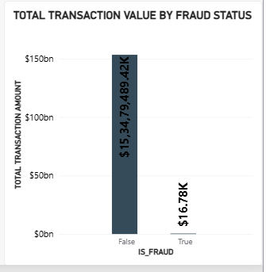
Figure 7: Total Transaction Value by Fraud Status
A Column Chart compares the total transaction value for records marked False and True in the IS_FRAUD field.
The chart shows a much higher transaction value for the False group (about $153.48bn) than for the True group (about $16.78K). This highlights the large difference in transaction value between the two fraud-status groups.
Purpose:
- To compare the financial value of fraud and normal activity.
- To understand the monetary exposure from fraud.
- To support the donut chart with value-based evidence.

. Slicers Used
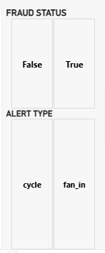
Figure 8: Fraud Status and Alert Type slicers
Two slicers are shown on the interactive dashboard to let users filter the report:
- Fraud Status (False / True)
- Alert Type (cycle / fan_in)
The slicers allow users to focus the dashboard on a selected fraud status or alert type. For example, choosing True under Fraud Status focuses the visuals on transactions flagged as fraudulent, while selecting cycle or fan_in narrows the alert analysis to that type.

9. Interactive AML Dashboard
The second page, INTERACTIVE AML DASHBOARD, keeps the same main charts and KPI cards and adds slicers for Fraud Status and Alert Type. These controls allow the user to explore different parts of the data without changing the report layout.
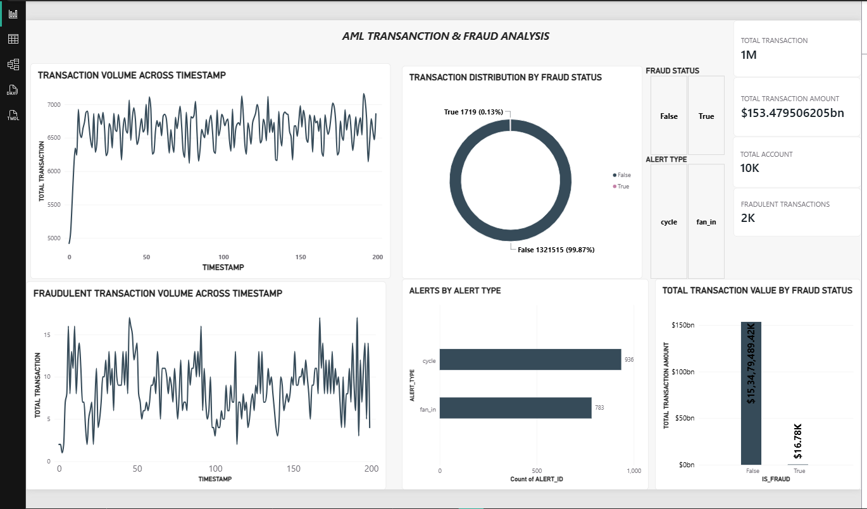
Figure 9: Interactive AML dashboard with slicers

10. Tooltip Page
The third page, AML TOOLTIP, displays KPI cards for Total Transaction, Total Transaction Amount and Fraudulent Transaction. This page is designed to show key figures in a compact tooltip view when the user hovers over a chart.
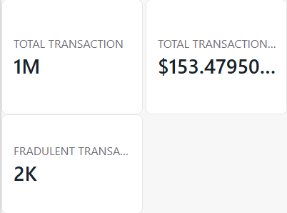

Figure 10: AML tooltip page

11. Key Insights
- The dashboard reports approximately 1M total transactions, 10K accounts and a total transaction amount of about $153.48bn.
- Fraudulent transactions account for about 0.13% of the distribution (shown as 1,719 in the fraud-status chart), while the KPI card rounds fraudulent transactions to 2K. The transaction value for the True group is about $16.78K.
- Overall transaction volume rises quickly at the beginning and then fluctuates within a fairly steady range. Fraudulent transaction volume shows frequent peaks and dips.
- CYCLE alerts (936) are more frequent than FAN_IN alerts (783).
- The Fraud Status and Alert Type slicers make it easier to focus on selected data, and the tooltip page provides a compact view of key figures.

12. Conclusion
The AML Transaction & Fraud Analysis dashboard turns transaction data into a clear visual summary. KPI cards show the main figures, line charts display transaction activity over time, the donut chart compares fraud status, and the bar and column charts compare alert types and transaction values. The slicers and tooltip page make the dashboard easier to explore.

